GANESH M
192524034

Experiment 2: Cloud-Based Flight Reservation System (SaaS)
AIM:
To create a simple cloud software application for a Flight Reservation System using a Cloud Service Provider to demonstrate the Software as a Service (SaaS) model.
PROCEDURE:
- Sign in to the Cloud Service Provider platform and create a new application named SkyBook Flights.
- Create the Flight Booking form and add the fields: Passenger name, Flight number, Origin, Destination, Travel date, Class, Seat number, and Status.
- Configure Class and Status as dropdown fields with predefined choices.
- Save the form and enter sample passenger bookings to test the application.
- Verify that bookings can be searched and filtered by flight number and status.
- Publish the application and access it through a web browser to demonstrate SaaS.
SCREENSHOT:
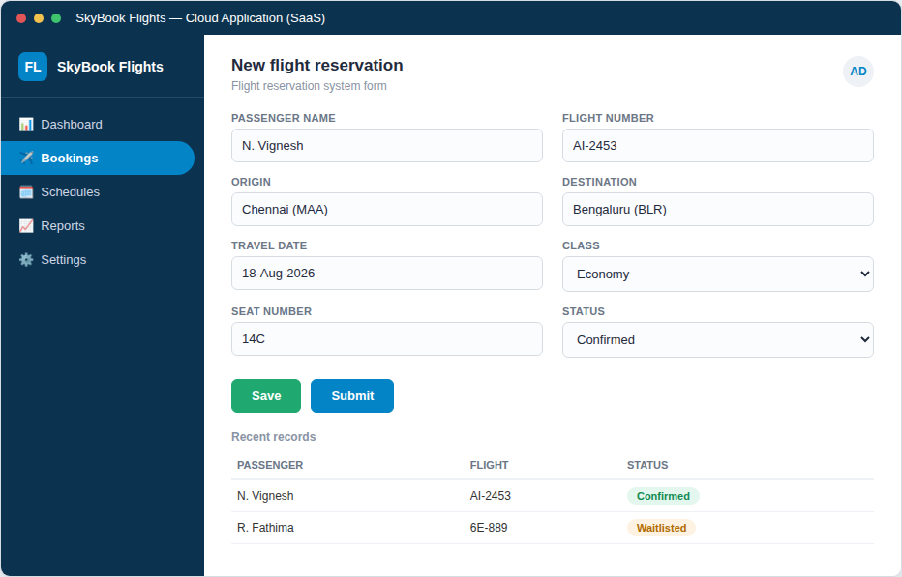

RESULT:
A cloud-based Flight Reservation System was successfully created. The application captured passenger and flight details correctly and was accessible through a web browser, demonstrating the Software as a Service (SaaS) model.

